Verde Salsa
Ingredients
- ½ cup Cilantro
- ½ cup Onion
- 1 Jalapeno
- 6 Tomatillos
- 3 Garlic cloves
- Salt & Pepper to taste
Note: This recipe will make 2 cups of salsa.

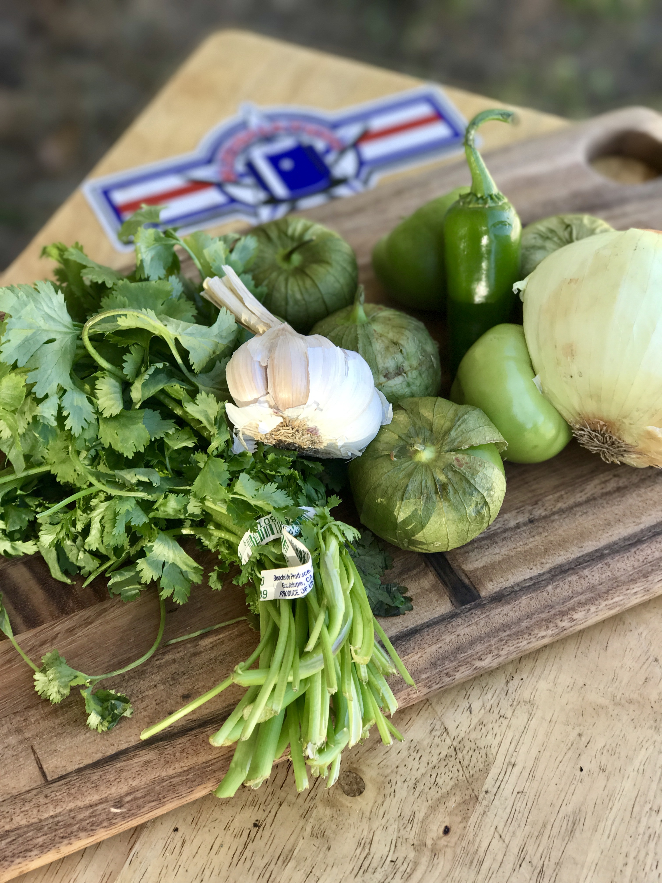

Step 1- Boil the Tomatillos and Jalapeno for five minutes.
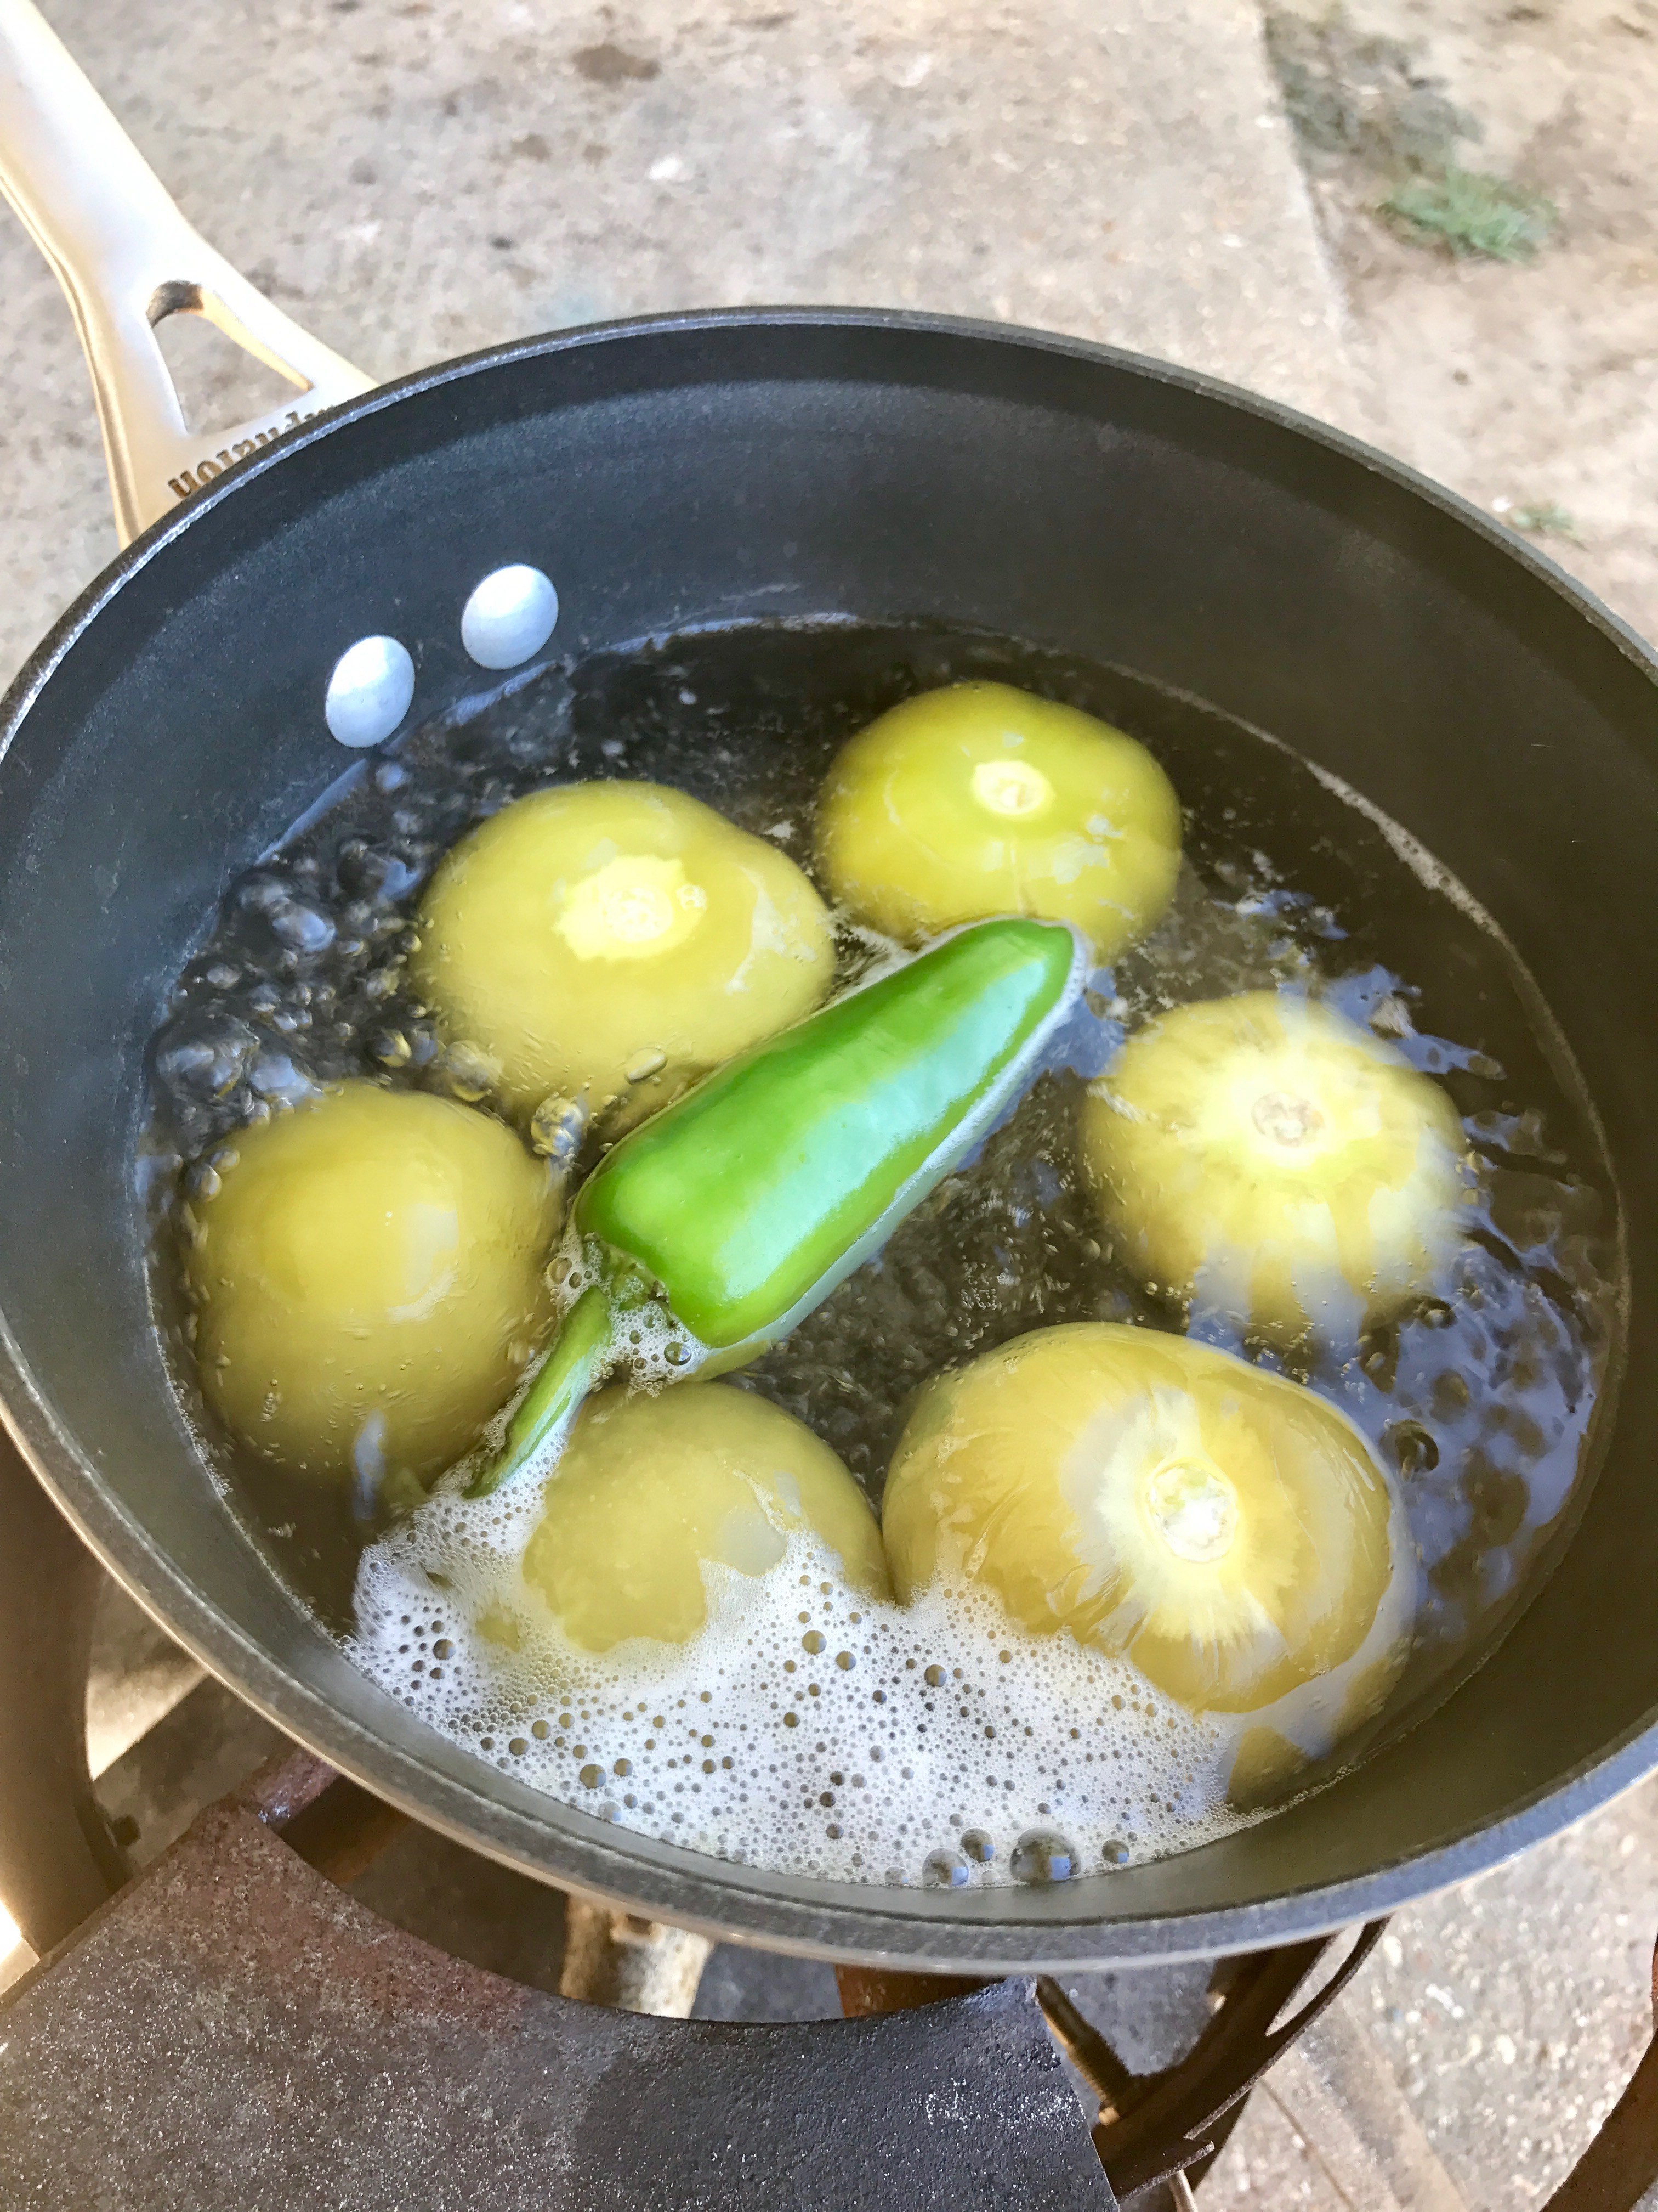

Step 2 – Give the Cilantro, Onion, and Garlic a rough chop.

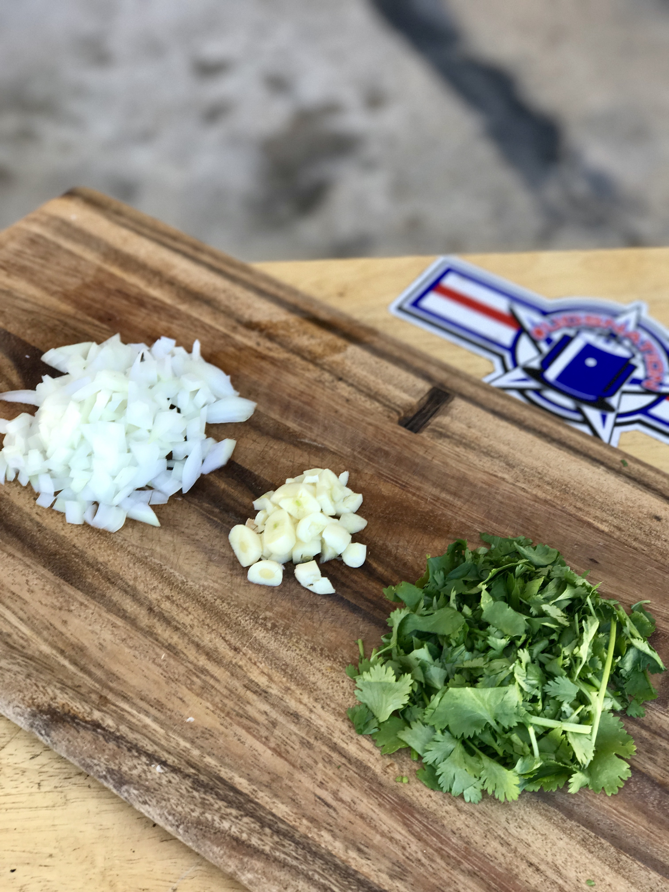

Step 3 – let the Tomatillos and Jalapeno cool and then add everything into a blender and pulse until consistency is smooth. At this point add desired salt and pepper.

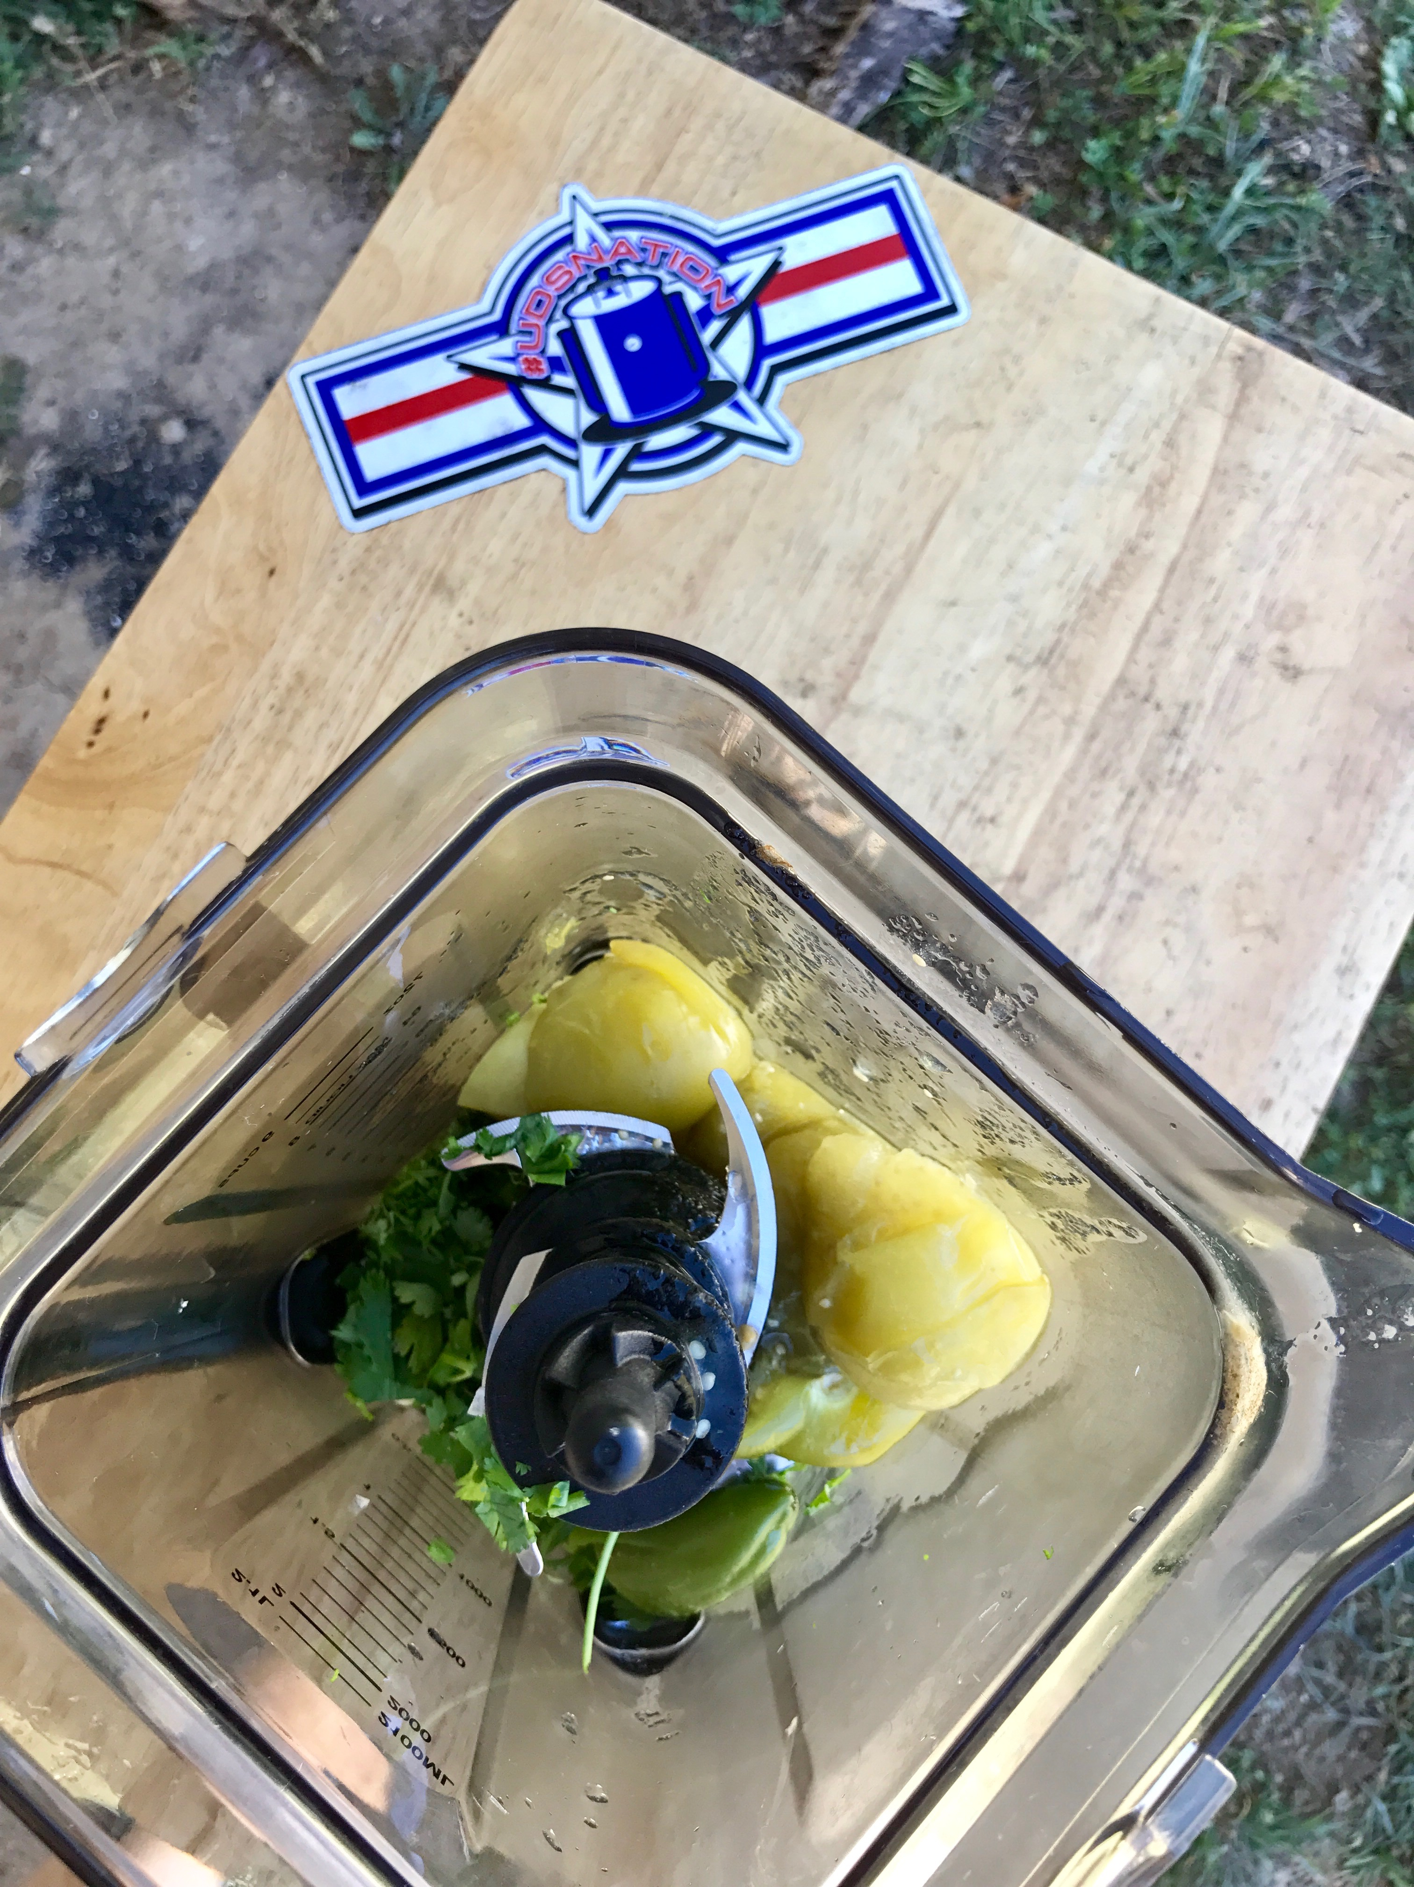

Step 4 – Place in a container and let it rest for at least two hours before serving.
